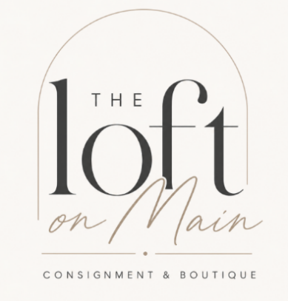
Consignment Agreement
Item Acceptance
All items are accepted at the sole discretion of the store based on brand, condition, style, and demand.
Must be on-trend ✔ Like-new condition or Excellent Condition ✔ Seasonal styles

Consignor Information
Consignor Name: Enter name
Address: Enter Address
Phone: enter phone number Email: enter email

This agreement is made between:
Consignor: type your name here and The Loft on Main Consignment & Boutique

Authenticity
Initial here
- Consignor guarantees all items are authentic (luxury brand).
- Our team is certified in authenticating and will verify all items
- If our team cannot authenticate an item, we reserve the right to reject or remove items suspected of being counterfeit.
- We use Entrupy for secure authentication.

Pricing
Initial here
- Our team determines final pricing based on market value and condition.
- Prices may be reduced at the store’s discretion to promote sales closer to the contract end date.

Consignment Period
- Standard consignment period for items under $100 will be displayed for 60 days. After 60 days you can choose to re-consign your items if we have the space
- Items priced at $100 and over will be displayed for 120 days. After 120 days you can choose to re-consign your items if we have the space
Unsold Items
Must be picked up within 7 days of expiration of your consignment agreement (after the 60-day period).

**It is your responsibility to communicate with us if you cannot pick up within the required timeframe, we ask you to be clear with us so that we can plan accordingly**

**Unclaimed items may be donated or re-stocked into our store and clients will NOT receive commission for the sale**

Consignor/Boutique Commission Payout

- $0-$299 40% to consignor 60% to the loft on main
- $300 and above 50/50 Split

Payout Method
*Payouts are issued on the 15th of each month*
- ACH ($2.50 processing fee)
- Check ($2.50 processing fee)

Collaborations
The loft on Main collaborates with other businesses and we attend events such as Pop-Up events, Markets, Holiday fairs, Seasonal Fairs etc. We hand select a few pieces from our client’s inventory to feature and sell at the event. We choose items that we feel confident selling.
This does not affect your consigning agreement with The Loft, it does not affect your commission amount, and it does not affect your items negatively.

Liability
The loft on Main Consignment & Boutique is not responsible for loss, theft, or damage, though reasonable care will be taken. The Loft on Main is fully insured.

By signing below, you agree to the terms and conditions of this agreement.
Signature (Consignor): Type your name here

